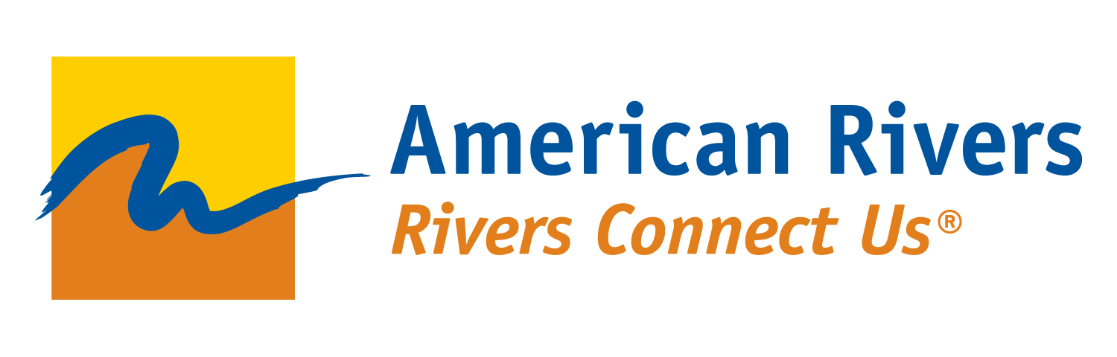

Connecting Communities to Rivers

Grant Application

October 2015

American Rivers is providing financial support for projects that connect communities in the Intermountain West to their hometown rivers by improving family-friendly recreational opportunities and protecting their rivers and surrounding landscapes. These projects provide communities with multiple layers of benefits. Funding will be provided for action-oriented projects that connect people to their rivers through recreation; establish a strong sense of river and land stewardship; and have clear and identifiable community, recreation, conservation and economic benefits.

American Rivers protects wild rivers, restores damaged rivers, and conserves clean water for people and nature. Since 1973, American Rivers has protected and restored more than 150,000 miles of rivers through advocacy efforts, on-the-ground projects, and an annual America’s Most Endangered Rivers ® campaign. Through our Blue Trails program we connect people to their hometown rivers through family-friendly recreation such as fishing, boating, and hiking and inspire them to see their rivers as valuable resources worthy of protection. Our belief is that once people have an opportunity to explore and enjoy their rivers and lands, they will be more likely to protect them.

APPLICATION FORM
Please save the application form as a PDF document. The file name should include the name of your organization and project.

Applications must be received by December 1, 2015.

Grant applications should be emailed to Connecting@AmericanRivers.org.

For a list of Frequently Asked Questions, please visit BlueTrailsGuide.org/Grants.

Organization Information

Legal name of organization (and fiscal sponsor if necessary):

Name of project contact:

Phone:

Email:

Mailing address:

Website:

Employer Identification Number:

Organization’s mission statement:

Limits of organizational general liability insurance:

Request

Project name:

Type of project (select all that apply):

Planning, outreach and communication activities
Collaboration between stakeholders
River recreation improvements
River protection and restoration efforts

Geographic area served including city, county, state. (The entire project area must be located within Colorado, Idaho, Montana, New Mexico and Wyoming):

Project start date:

Project end date:

Projects must be completed by December 31, 2016. Describe any potential delays in project implementation.

Project overview description (500 character limit):

Statement of need (1,000 character limit):

Project description (2,500 character limit):
Describe your project and how it supports the goals of this grant program (see introductory paragraph above). Address all of the following questions in your description.
- How does your project improve low-cost recreational opportunities?
- How does your project protect and/or restore your river and surrounding landscapes?
- How does your project support other conservation efforts in the region?
- How does your project connect communities to protected areas? Is it adjacent to protected areas and/or areas prioritized for future protection?
- How does your project enhance local economies?
- How does your project enhance underserved communities?
- What partners are you collaborating with on this project?
- How does your project engage and/or serve youth and families?
- Describe the current level of community, political and/or business support for your project or describe your plans to develop strong support.
- How will you communicate the results of the grant with your local community?

Total project cost:

Grant amount requested:

Amount and source of match (required for requests $15,000 and greater):
A match of 50% of the grant request is required for grant requests between $15,000 and $25,000. For those proposals less than $15,000 a match is not required. For example, if you request $15,000, the required match would be$7,500.
Eligible match requirements include funds from foundations or other entities, as well as in-kind services (e.g. staff time and benefits, volunteer hours, donated goods). Your match must be related to the Connecting Communities to Rivers Grant Program and can only be counted once. It cannot be counted as match for another grant.
Describe the source of your match. If your match includes staff time and benefits, please include the names of the staff people, dates, and what they did or will do on the project and the source of the funding used as match.
If your match includes volunteers, please include the number of volunteers, the amount of total volunteer hours and the value of $22.55 per hour per volunteer (e.g. 10 volunteers for 4 hours each at $22.55 per hour per volunteer = $902.00).
Your match could include use of equipment. For example, an outfitter donates canoes for a community event (e.g. Blue River Outfitter donated 10 canoes at the hourly rate of $20 per canoe = $200). Please include the name of the entity donating the equipment.

Evaluation

Evaluation metrics (1,000 character limit):
Describe a successful project outcome and illustrate how your project relates to the goals of the grant program. Describe how you intend to measure project success at the end of grant term and, if the grant term ends prior to project completion, at project completion. Please use clear language to describe anticipated project outcomes, and ensure that metrics are both directly related to those outcomes and are specific as possible.
An example of a project outcome could include hosting two community river events. A metric related to this could be the number of people in attendance and the number of community sponsors. Another outcome could be 2 acres of restored riparian habitat. The metrics related to this could include the number of volunteers engaged, the number of invasive plants removed and the number of native species planted.
Who will be involved in evaluating the project (e.g. staff, board, constituents, community members, etc.)? Who is responsible for the project’s success (specific staff, etc.)?

By signing below, I certify that the information contained in this application is true the best of my knowledge.

CEO/Executive Director Date
Upload Files
Please save these below files in one PDF document, if possible. The file name should include the name of your organization and project.

- Project budget and, if necessary, source of match
- Annual operations budget
- W9
- 990, if applicable
- IRS exemption letter, if applicable
- Optional: 1 PDF map of project/project site and river
- Optional: written or video testimonials of the project
- Optional: other relevant supporting documents or letters

